Task on Load Balancers

- Configure Classic Load balancer.
- What is a Classic Load Balancer?
A Classic Load Balancer (CLB) is the original AWS load balancer. It distributes incoming application or network traffic across multiple EC2 instances to improve availability and fault tolerance. CLB works at Layer 4 (TCP/SSL) and Layer 7 (HTTP/HTTPS).
Use cases:
- Simple load balancing of HTTP/HTTPS applications.
- Distribute traffic across multiple EC2 instances in one or more Availability Zones (AZs).
- Health check of EC2 instances to route traffic only to healthy ones.
Key features:
- Supports HTTP, HTTPS, TCP, and SSL protocols.
- Performs health checks on backend instances.
- Supports sticky sessions (optional).
- Can span multiple AZs for high availability.

2. Pre-requisites
Before configuring a CLB, ensure:
- You have an AWS account.
- At least two EC2 instances running in the same region.
  - These instances should have security groups allowing inbound traffic on your app ports (e.g., HTTP 80, HTTPS 443).
- EC2 instances should have a public/private subnet depending on whether the CLB is internet-facing or internal.
- Optional: A certificate in AWS ACM if you want HTTPS support.

Configure a Classic Load Balancer
Step 1: Open the EC2 Console
- Go to AWS Console → EC2 → Load Balancers → Create Load Balancer → Classic Load Balancer.
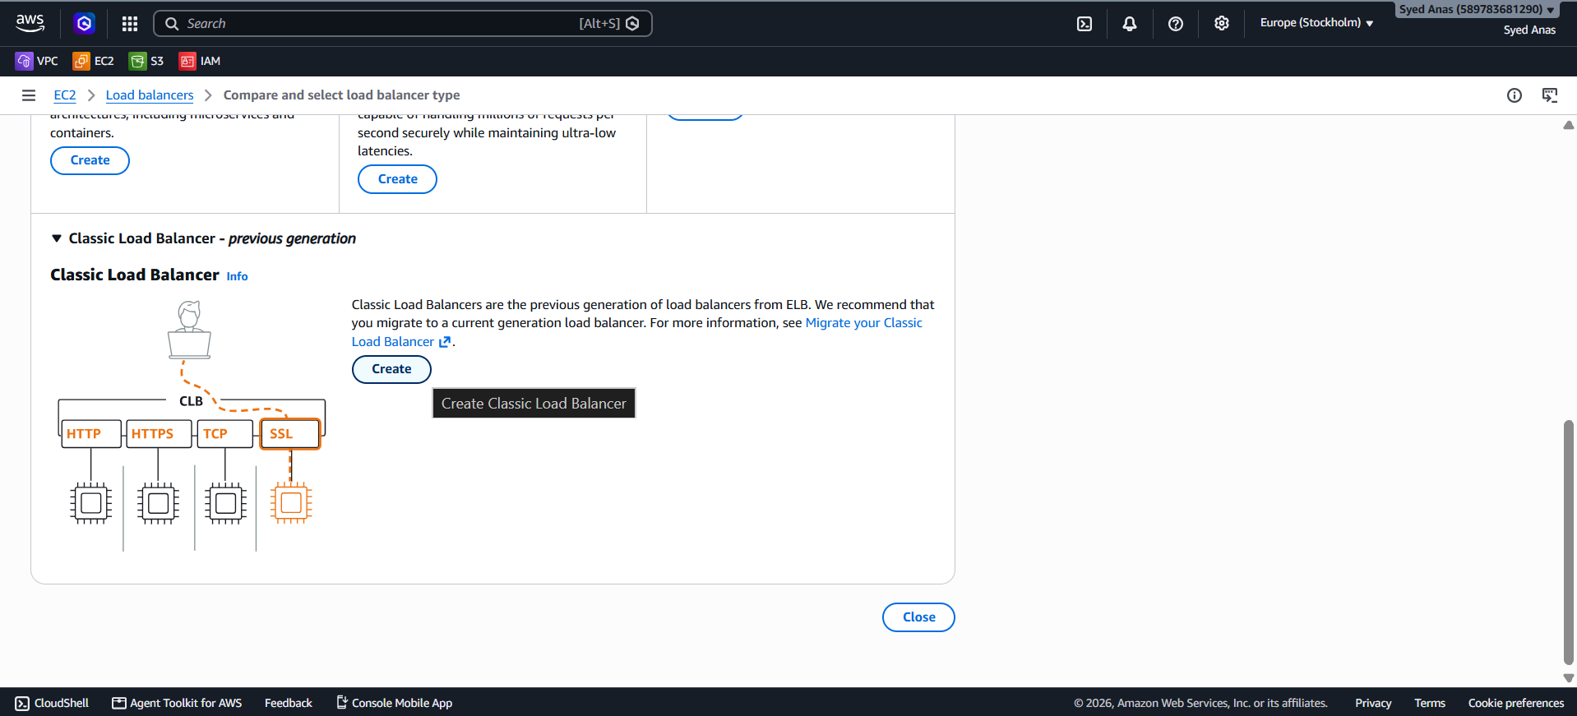

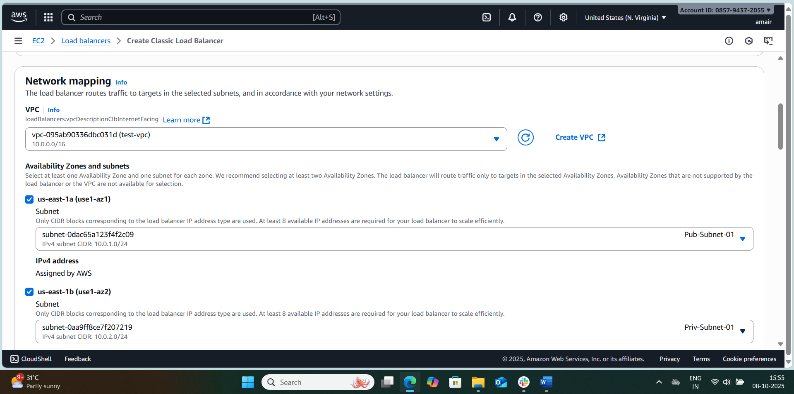

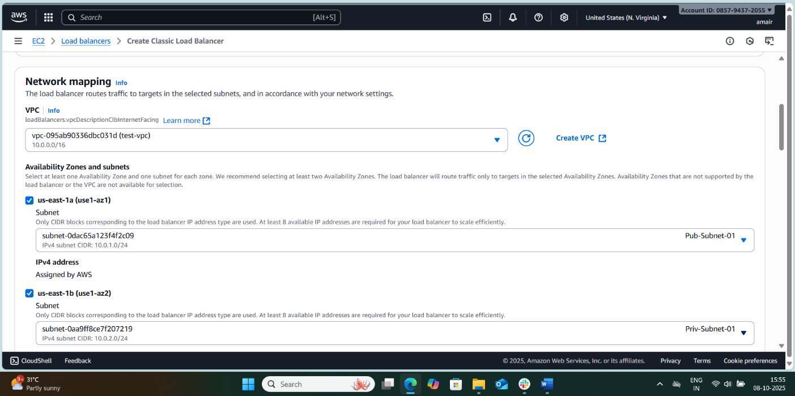
Step 2: Configure Load Balancer Basics
- Name: Give your load balancer a unique name.
- Scheme: Choose either:
  - Internet-facing (publicly accessible)
  - Internal (private for internal network)
- Listeners: Define which protocols and ports the CLB will use.
  - Example:
    - Load Balancer Protocol: HTTP
    - Load Balancer Port: 80
    - Instance Protocol: HTTP
    - Instance Port: 80
For HTTPS, you will need a certificate from ACM.
Step 3: Configure Availability Zones
- Select the VPC where your instances are deployed.
- Choose subnets in multiple Availability Zones for high availability.
- The CLB will distribute traffic across these AZs.

Step 4: Configure Security Settings (Optional for HTTPS)
- If you are using HTTPS, you need to:
  - Select an SSL certificate (from ACM or upload your own).
  - Choose security policy (default or custom).
For HTTP, you can skip this step.

Step 5: Configure Security Groups
- Assign a security group for the CLB:
  - Allow inbound traffic on load balancer port (e.g., 80 or 443).
  - The instances’ security groups should allow traffic from the load balancer (or 0.0.0.0/0 for public access).

Step 6: Configure Health Check
- Health checks ensure traffic is only sent to healthy instances.
- Settings:
  - Ping Protocol: HTTP
  - Ping Port: 80
  - Ping Path: /index.html or /health
  - Response Timeout: 5 seconds
  - Interval: 30 seconds
  - Unhealthy threshold: 2
  - Healthy threshold: 5
Tip: Choose a lightweight page (like /index.html) to avoid heavy load on instances.

Step 7: Add EC2 Instances
- Select the EC2 instances to register with the CLB.
- The CLB will route traffic to these instances based on the health check.

Step 8: Add Tags (Optional)
- You can add tags for better management (e.g., Name: MyCLB, Environment: Dev).

Step 9: Review and Create
- Review all settings carefully:
  - Listeners, Subnets, Security Groups, Instances, Health Check.
- Click Create.

Step 10: Test the Load Balancer
- Once created, go to the Description tab → DNS Name.
- Open the DNS in a browser (e.g., http://my-clb-123456.elb.amazonaws.com).
- You should see the response from your EC2 instances.
- Refresh the page multiple times to see traffic distributed across instances.

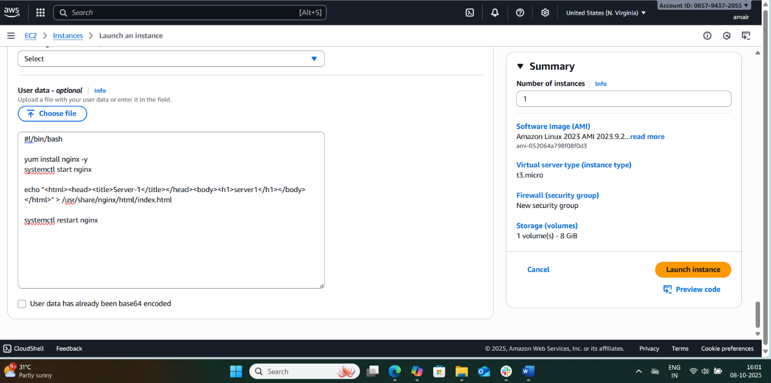

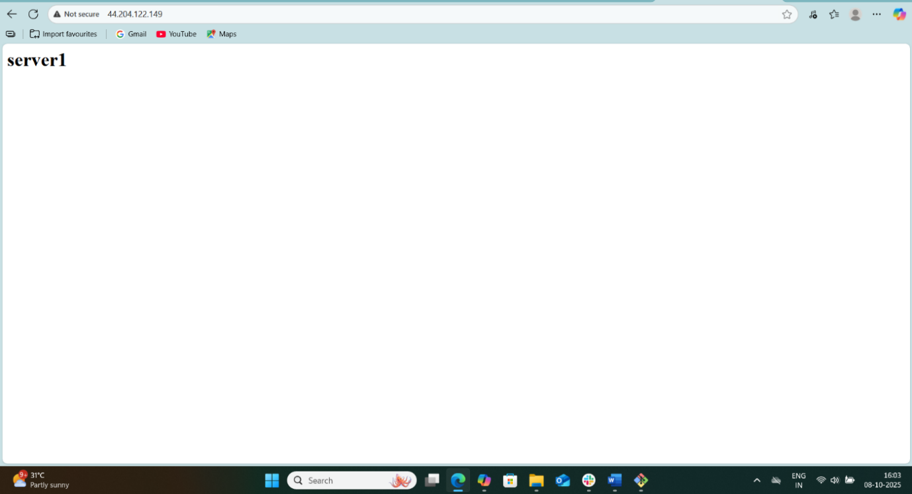
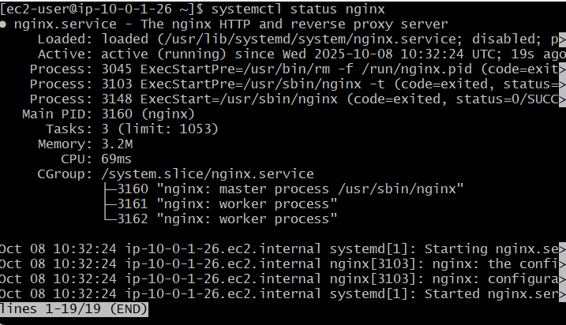

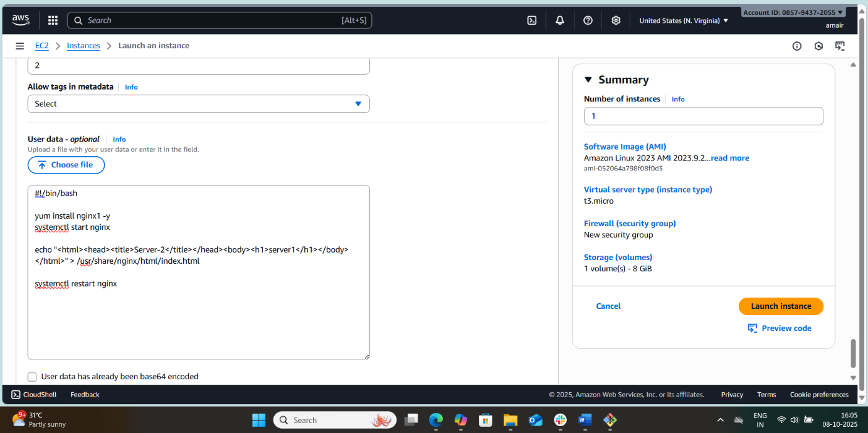



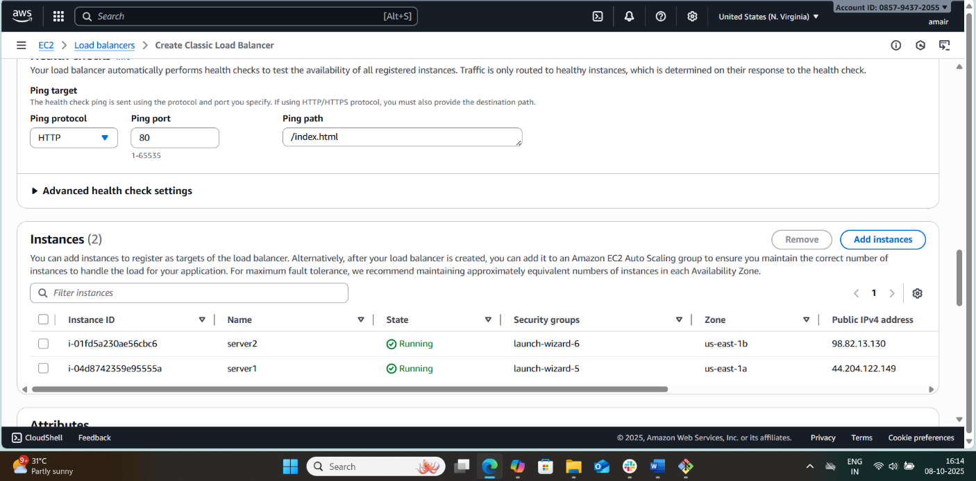

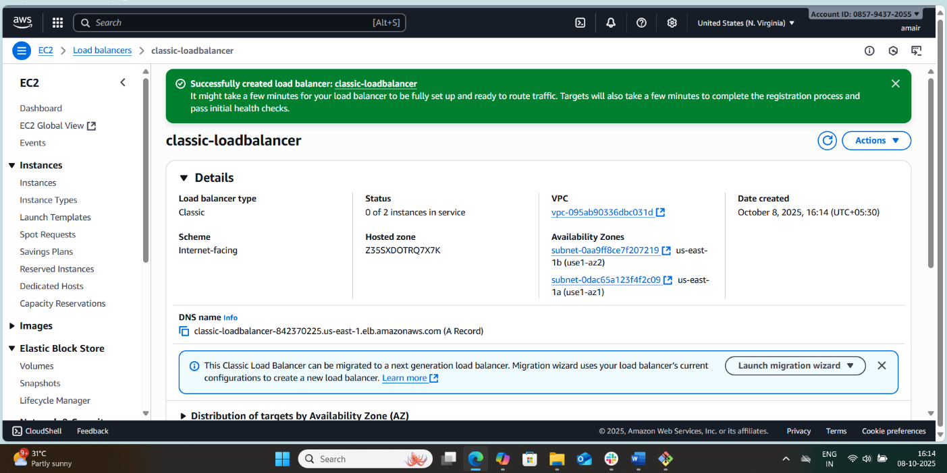

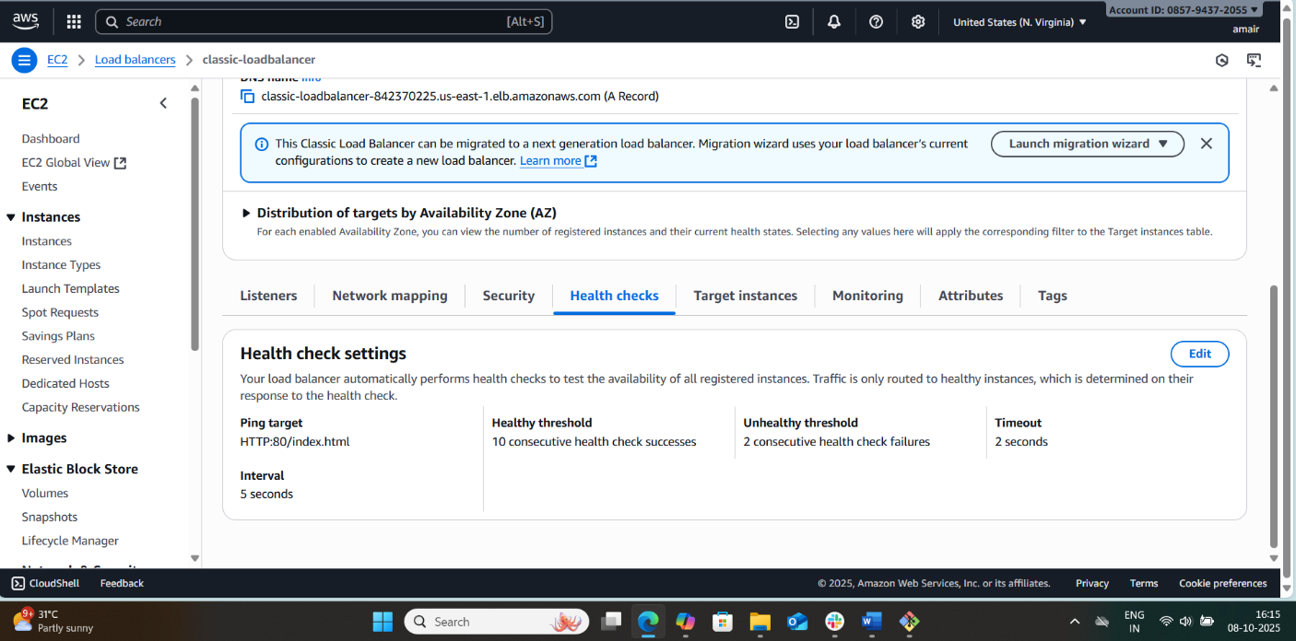

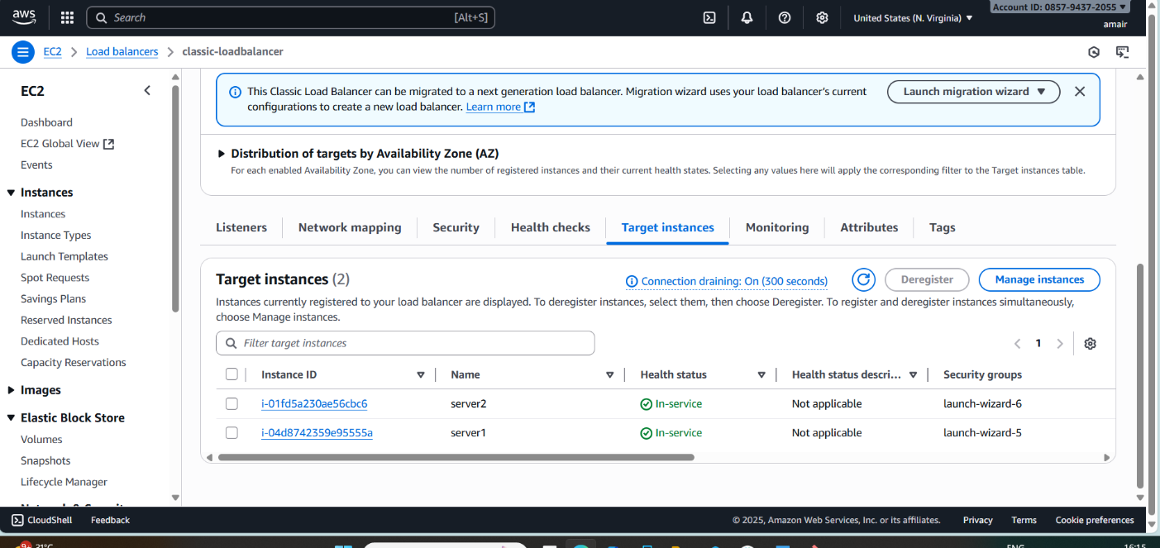

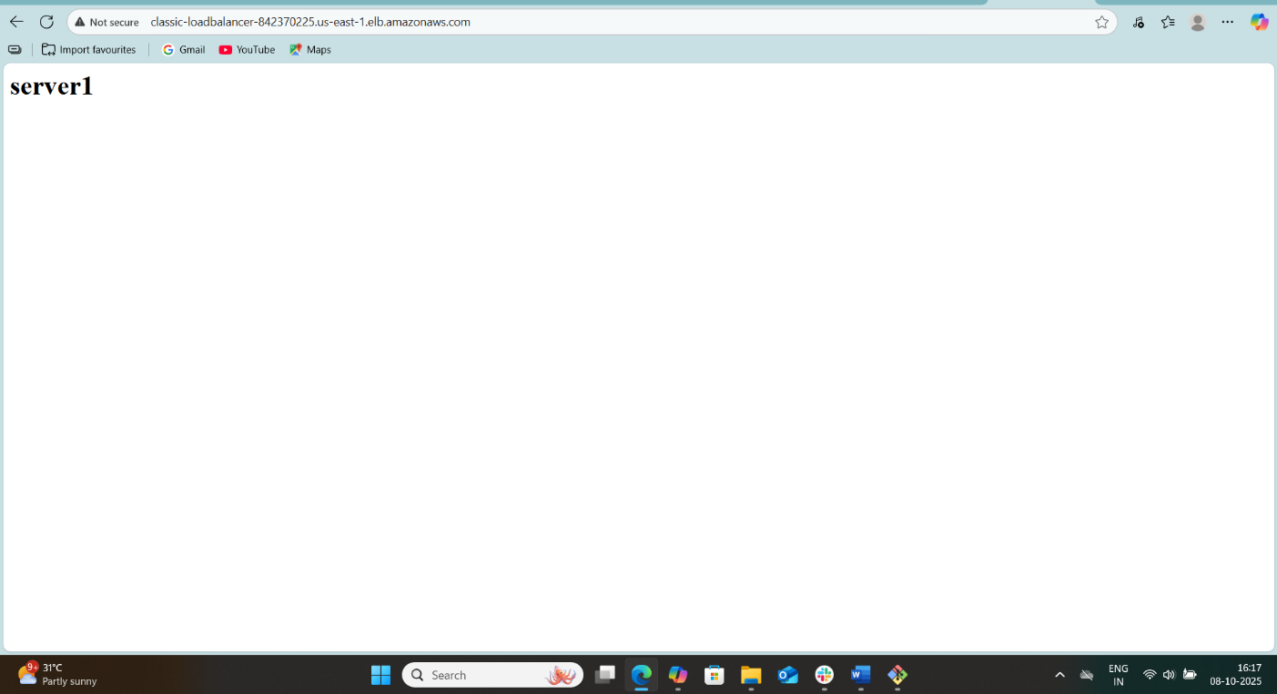
- Configure Application Load balancer.
Step 1: Understand What an ALB Is
An Application Load Balancer is a Layer 7 load balancer that routes HTTP/HTTPS traffic based on content. It can:
- Distribute traffic across multiple EC2 instances, containers, or IP addresses.
- Support host-based or path-based routing.
- Work with Auto Scaling to handle traffic spikes.
- Enable SSL termination for HTTPS.

Step 2: Pre-requisites
Before creating an ALB, ensure you have:
- VPC with public subnets in at least 2 Availability Zones (AZs).
- EC2 instances running in the public/private subnets with security groups allowing traffic on your app port (e.g., 80/443).
- Security groups for ALB:
  - Allow inbound traffic from the internet on port 80 (HTTP) or 443 (HTTPS).
  - Outbound traffic to your EC2 instances on the application port (80/443).

Step 3: Create the Application Load Balancer
- Open AWS Management Console → EC2 → Load Balancers → Create Load Balancer.
- Select Application Load Balancer.
- Configure Basic Settings:
  - Name: Give a descriptive name (e.g., my-app-alb).
  - Scheme: Internet-facing (for public apps) or Internal (for internal apps).
  - IP address type: IPv4 or dualstack (for IPv6 support).
- Network Mapping:
  - Select your VPC.
  - Select at least two public subnets in different AZs for high availability.
- Security Groups:
  - Attach a security group allowing inbound HTTP (80) and HTTPS (443) traffic.
- Listeners:
  - HTTP (port 80) by default.
  - Optionally, HTTPS (port 443) if SSL is required.
- Click Next: Configure Routing.

Step 4: Configure Target Group
- A Target Group is a set of resources (EC2, IP, or Lambda) the ALB routes traffic to.
- Settings:
  - Target Type: Instance (EC2), IP, or Lambda.
  - Protocol & Port: HTTP 80 or your app port.
  - Health Checks: ALB checks instance health before routing traffic.
    - Path: / (or /health if you have a health endpoint)
    - Protocol: HTTP
    - Healthy threshold: 3
    - Unhealthy threshold: 3
    - Interval: 30 seconds
- Click Next: Register Targets.
- Add your EC2 instances to the target group.

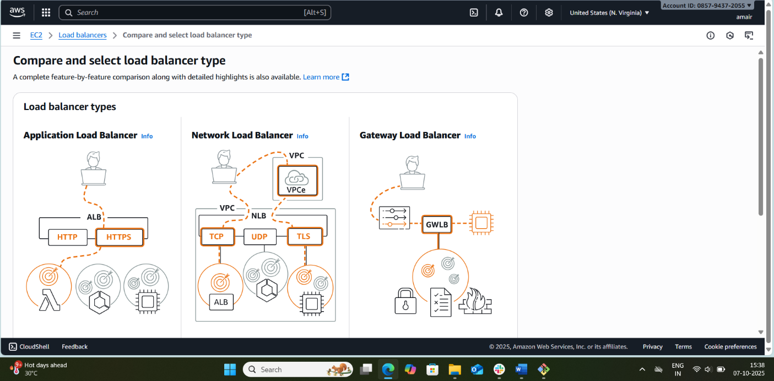
Step 5: Review & Create
- Review all settings.
- Click Create Load Balancer.
- It will take a few minutes to deploy.

Step 6: Update DNS (Optional)
- Once the ALB is active, copy its DNS name.
- Update your Route 53 or domain DNS records to point to this DNS for your website/application.

Step 7: Testing
- Open the ALB DNS name in a browser.
- You should see your application being served from one of the EC2 instances.
- To test high availability:
  - Stop one EC2 instance in the target group.
  - Refresh the browser; traffic should route to the healthy instance.

Step 8: Advanced Configurations (Optional)
- Path-based routing: e.g., /images → Target Group A, /api → Target Group B.
- Host-based routing: e.g., api.example.com → Target Group A.
- HTTPS/SSL: Attach a certificate from AWS ACM.
- Logging & Monitoring: Enable ALB access logs to S3 and monitor metrics in CloudWatch.
Security Considerations
- Use a separate security group for ALB and EC2.
- Only allow the ALB to communicate with EC2 on the app port.
- Enable HTTPS for secure communication.

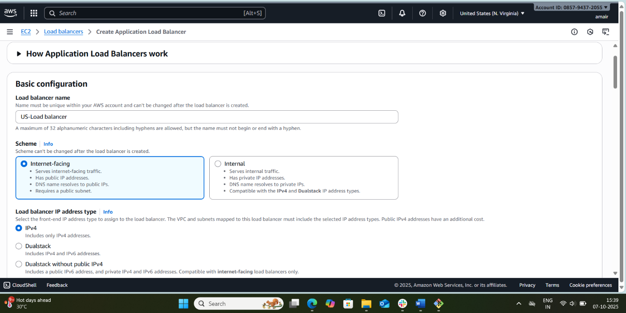

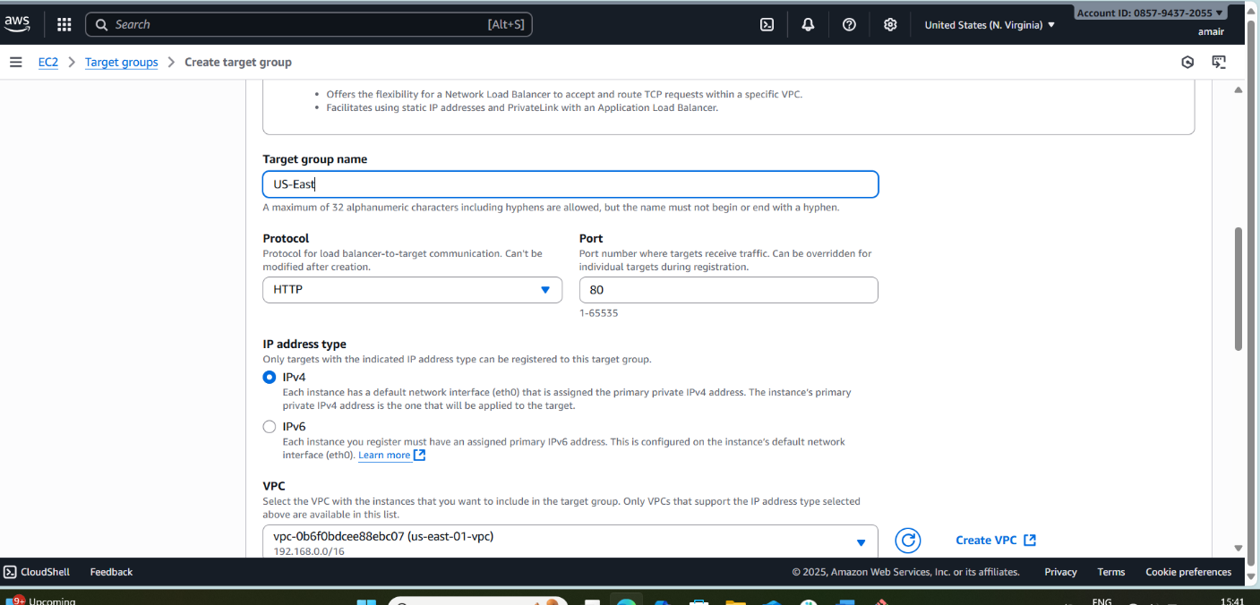

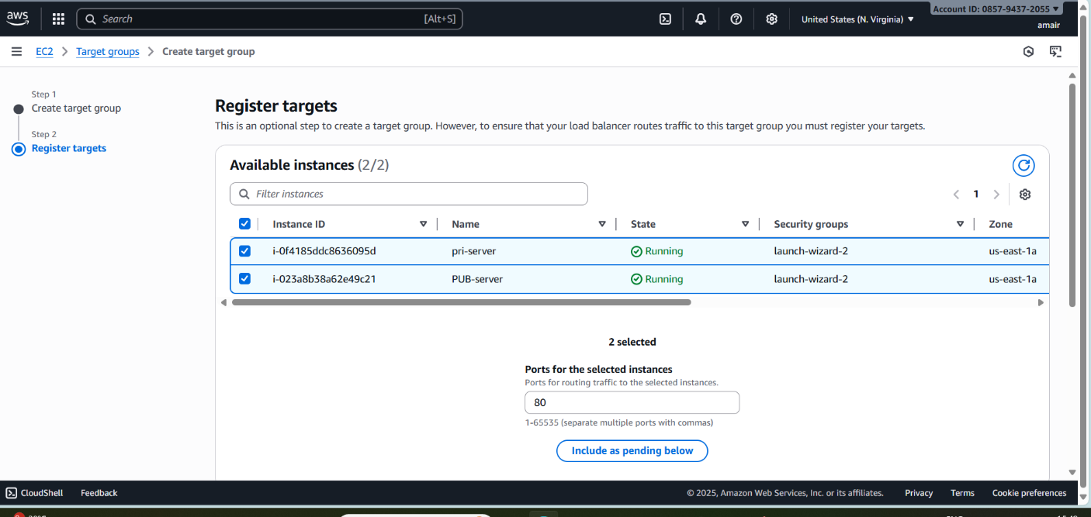

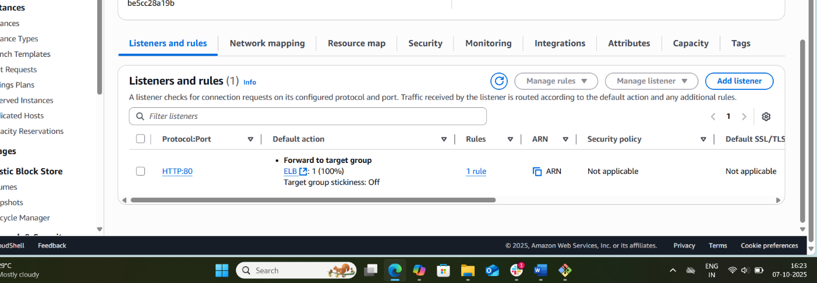

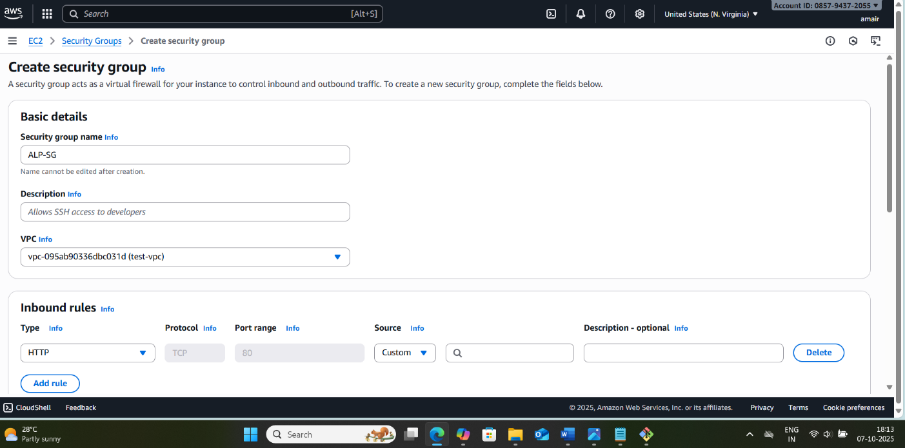

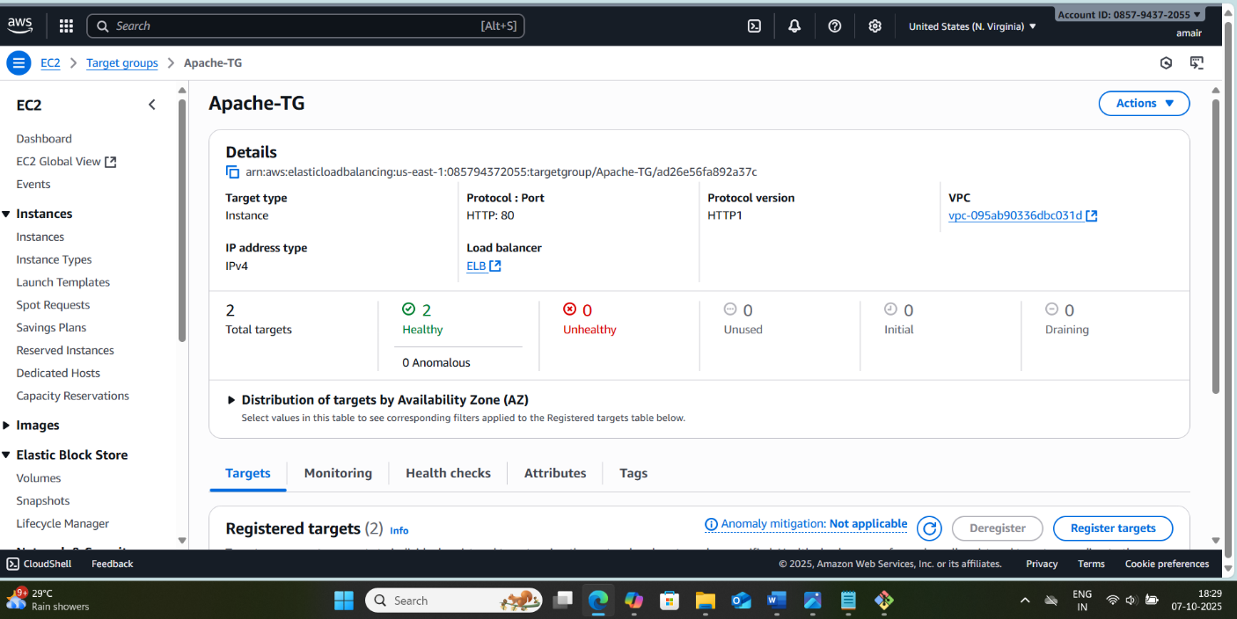

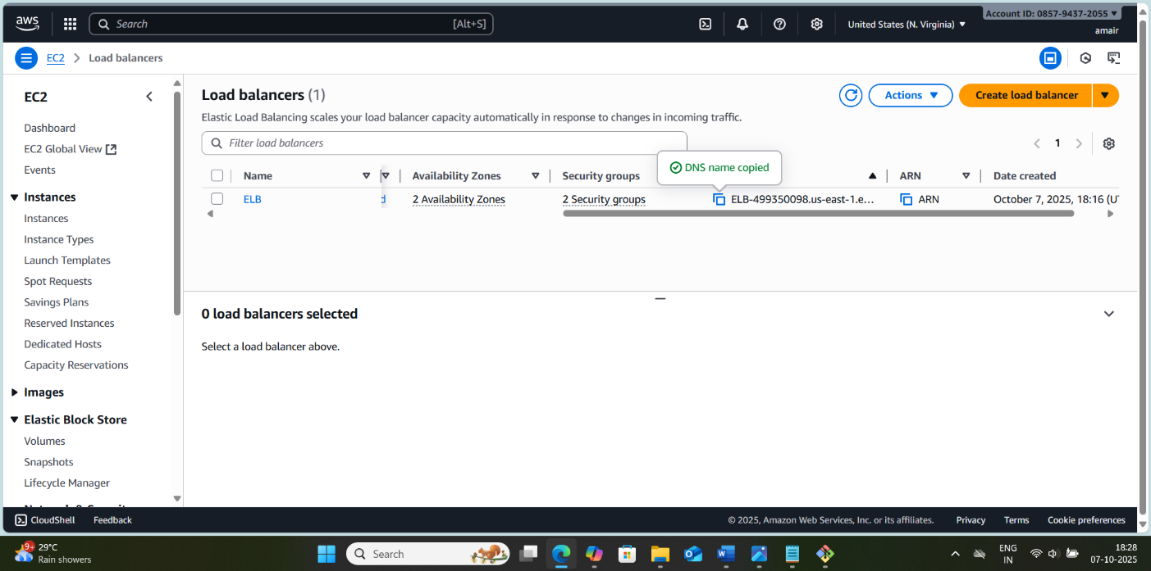

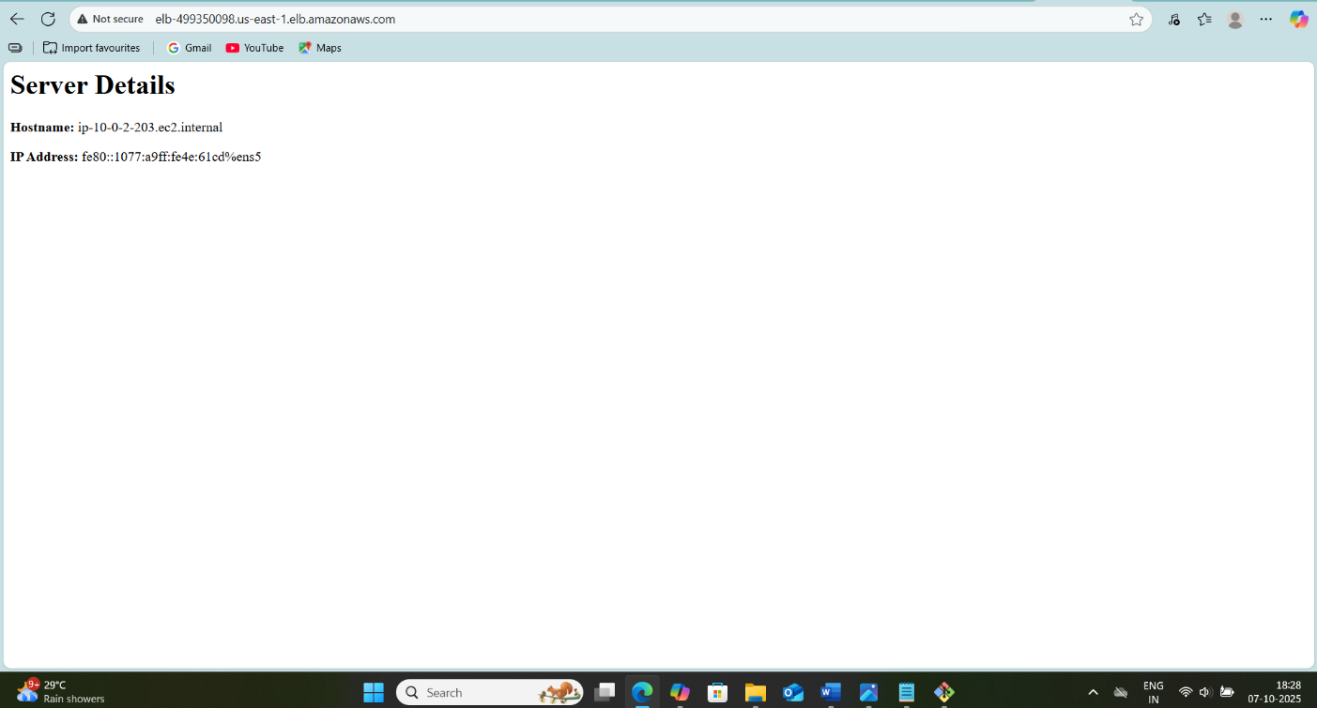



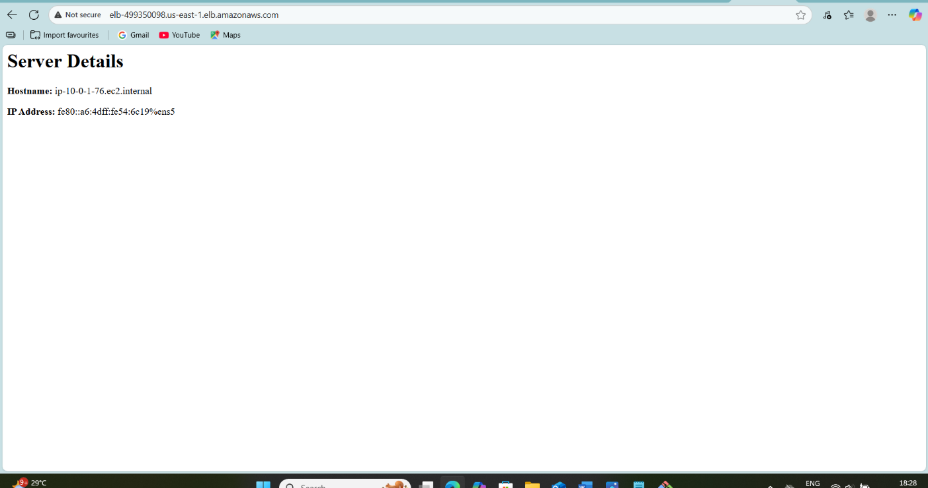
- Configure Network Load balancer.
Step 1: Understand Network Load Balancer (NLB)
- Purpose: NLB is used to handle TCP/UDP traffic at high throughput with low latency. It works at Layer 4 (Transport Layer) of the OSI model.
- Features:
  - Can handle millions of requests per second.
  - Static IP per Availability Zone.
  - Supports TLS termination (optional).
  - Can target EC2 instances, IP addresses, or Lambda functions.

Step 2: Prerequisites
Before creating an NLB, ensure the following are ready:
- VPC with at least two subnets in different Availability Zones (AZs) for high availability.
- EC2 Instances: Two or more instances running your application (e.g., web server).
- Security Groups:
  - NLB does not use security groups directly; however, your EC2 instances must allow incoming traffic on the port you plan to use (e.g., 80 for HTTP, 443 for HTTPS).
- Elastic IPs (optional): If you want static IPs for the NLB.

Step 3: Creating the Network Load Balancer
- Open AWS Console → Navigate to EC2 → Load Balancers → Create Load Balancer.
- Select Network Load Balancer.

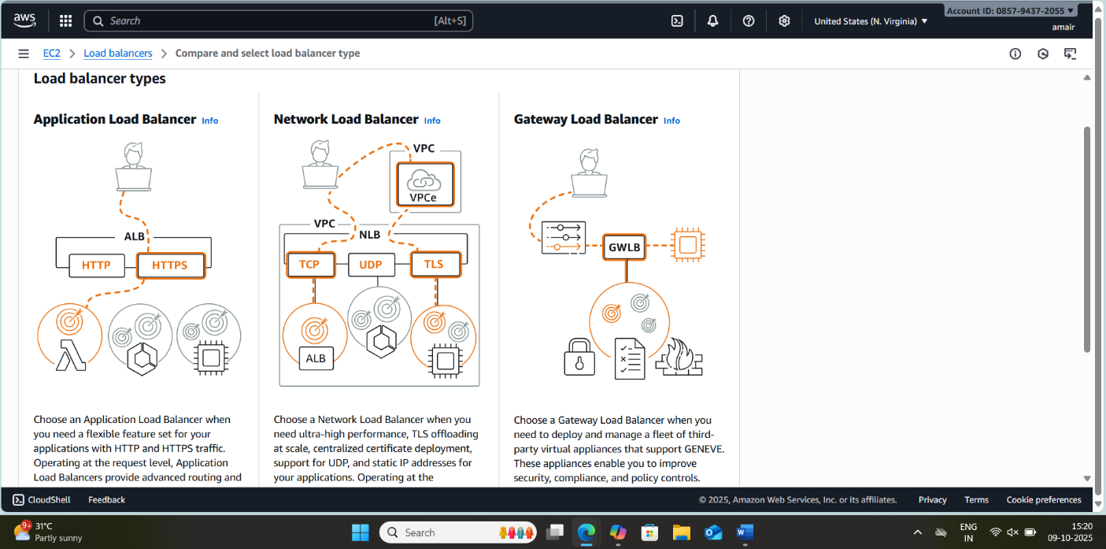

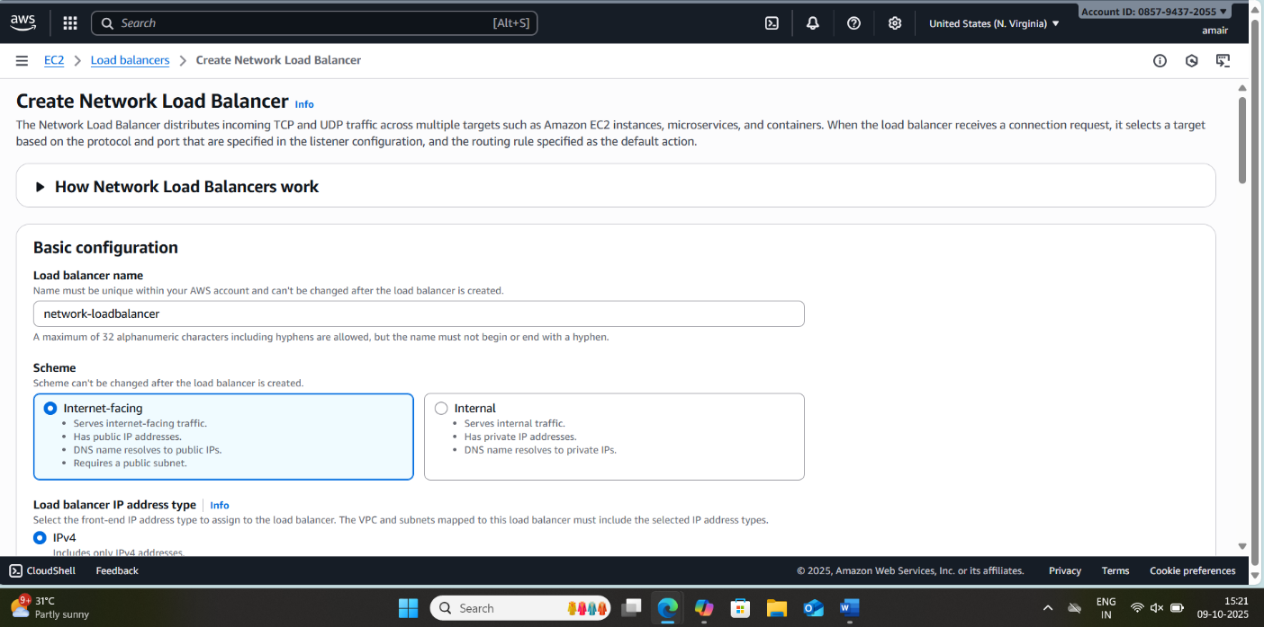
- Configure Basic Settings:
  - Name: Give your NLB a descriptive name.
  - Scheme:
    - Internet-facing → Publicly accessible (e.g., web app).
    - Internal → Only accessible within VPC (e.g., backend service).
  - IP Address Type: IPv4 (default).
- Configure Listeners:
  - Default listener is TCP:80 (HTTP) or TCP:443 (HTTPS).
  - You can add additional ports if needed.
Step 4: Configure Availability Zones and Subnets
- Select the VPC where your instances are located.
- Select subnets in at least two AZs for high availability.
- NLB will automatically allocate a static IP per subnet or use your Elastic IP if assigned.

Step 5: Configure Target Groups
- Create a Target Group (or use an existing one):
  - Target Type:
    - Instance → EC2 instances.
    - IP → Specific IP addresses.
  - Protocol: TCP or UDP (matches your listener).
  - Port: The port your application is running on (e.g., 80).
  - Health Checks:
    - Protocol: TCP (for NLB, usually TCP health checks).
    - Port: Default or custom.
- Register Targets: Add your EC2 instances to the target group.

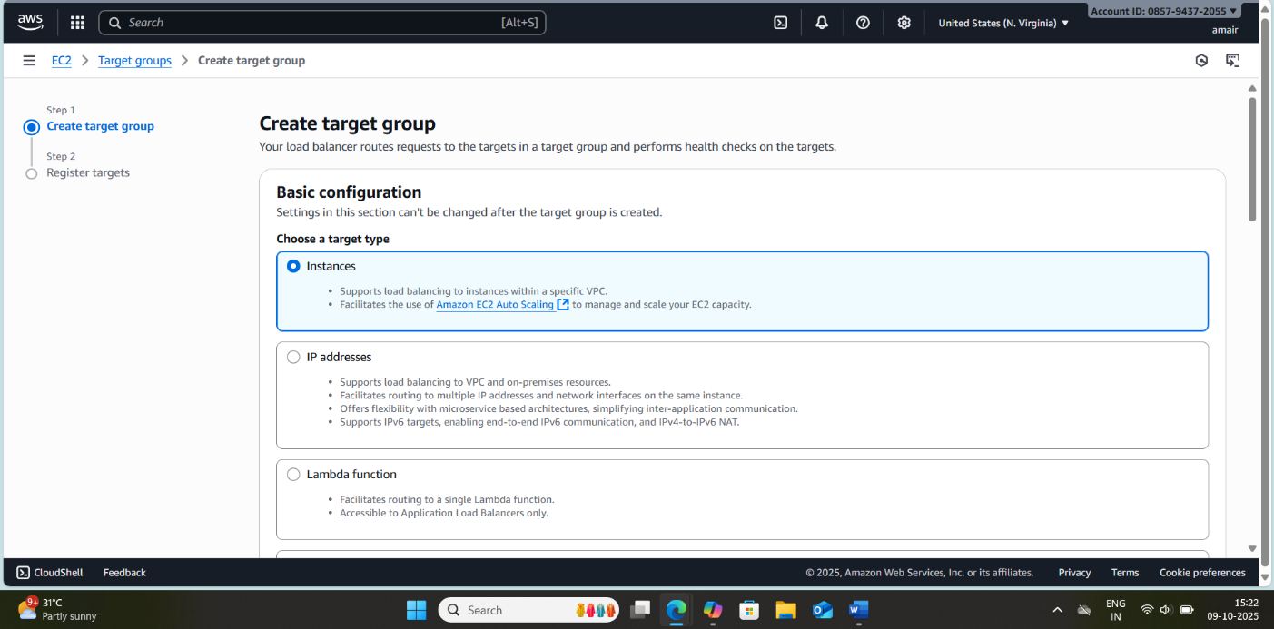
Step 6: Review and Create
- Review all settings: NLB name, scheme, listener, subnets, target groups.
- Click Create Load Balancer.

Step 7: Testing the NLB
- Once created, you’ll see a DNS name for the NLB (e.g., my-nlb-1234567890.elb.amazonaws.com).
- Open a browser or use curl to test:
- curl http://<NLB-DNS-Name>
- Verify traffic is distributed to your EC2 instances.

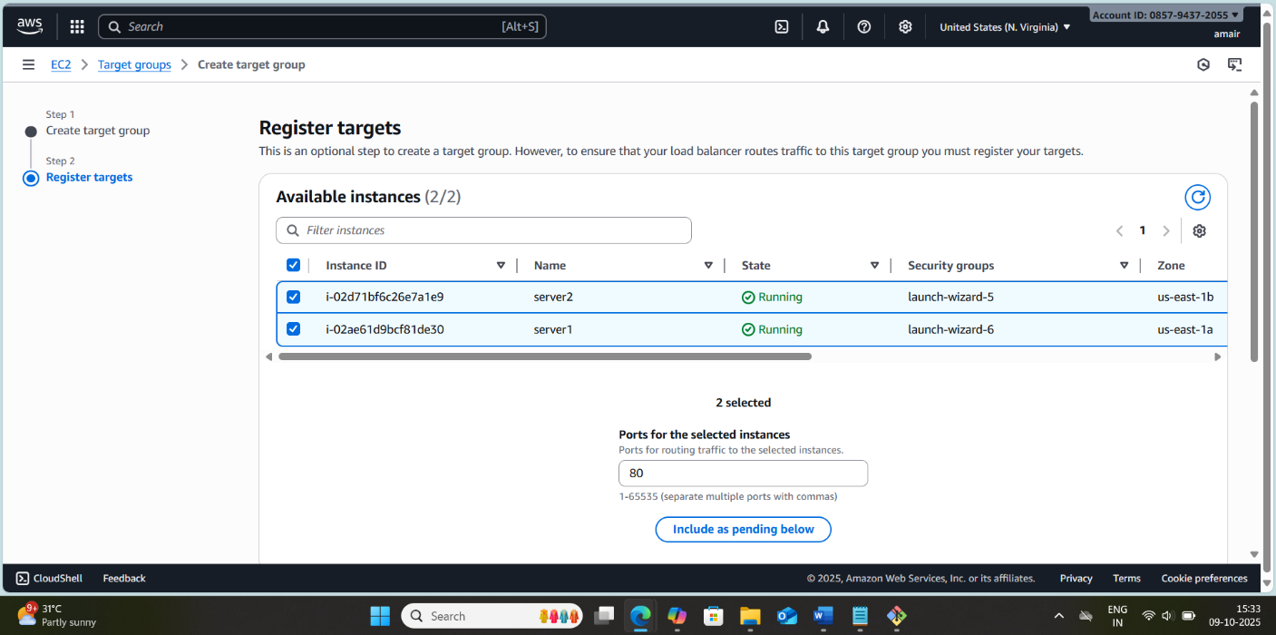
Step 8: Optional Configurations
- TLS Termination: If using HTTPS, create a listener on port 443 and attach an SSL certificate from AWS Certificate Manager (ACM).
- Cross-Zone Load Balancing: Enable to distribute traffic evenly across all AZs.
- CloudWatch Metrics: Monitor ActiveFlowCount, NewFlowCount, and ProcessedBytes for NLB performance.

- 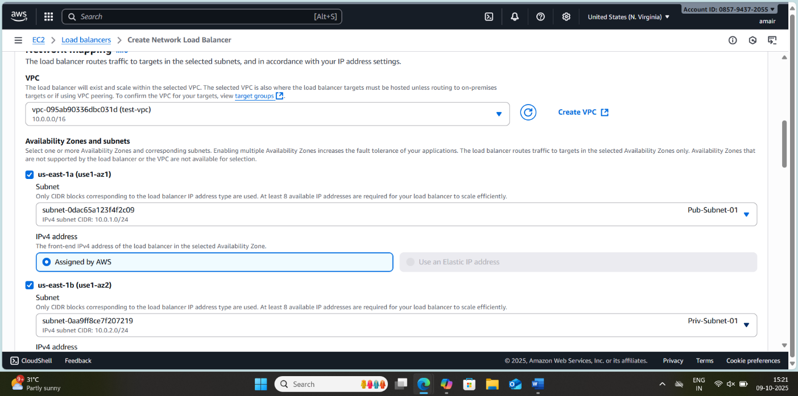

- 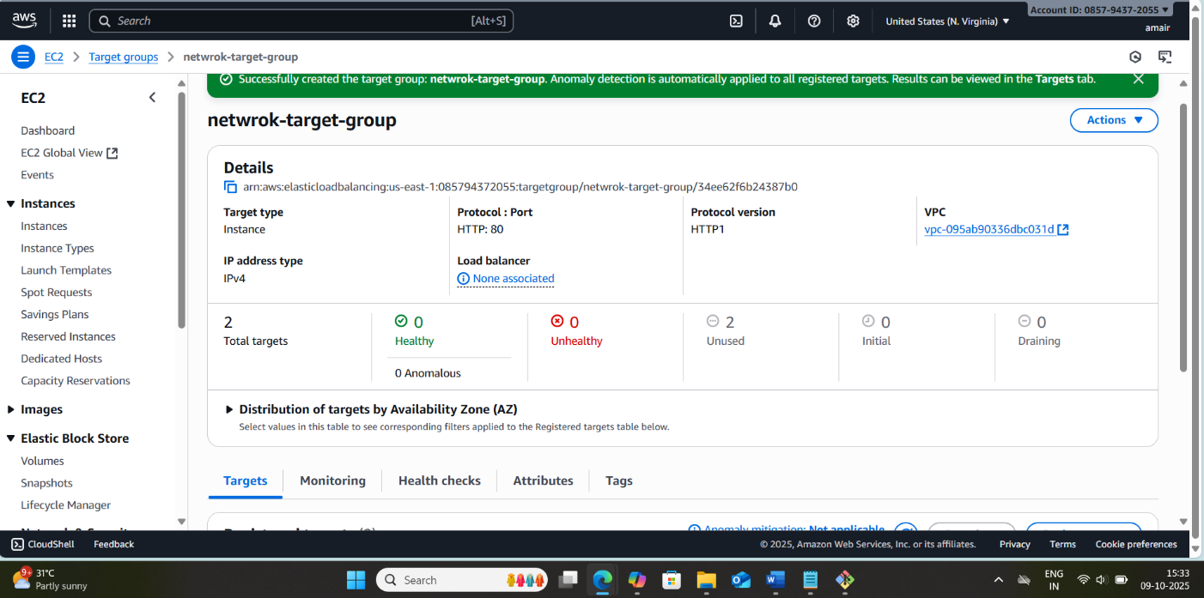

- 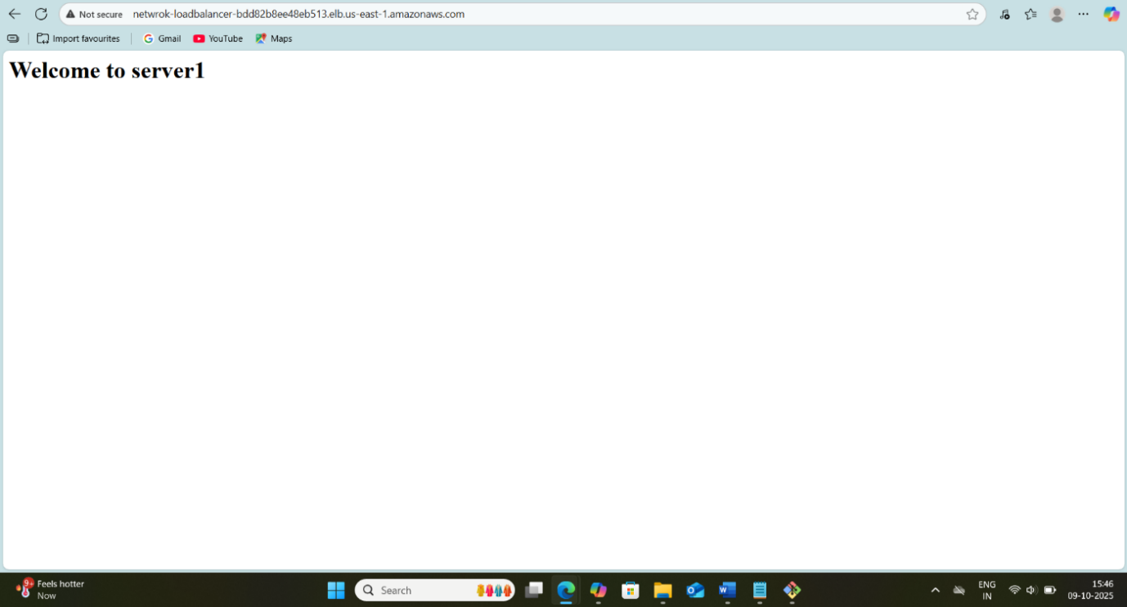

- 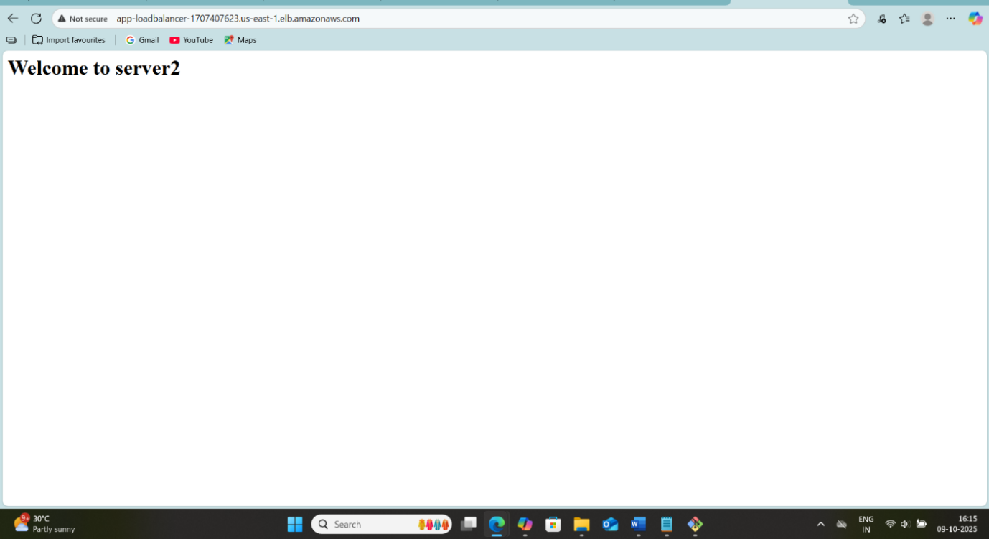
Important Notes
- NLB does not support sticky sessions (session persistence).
- Security is handled at the instance level; ensure your EC2 security groups allow NLB traffic.
- Health checks are crucial—if your instance fails, NLB will stop sending traffic to it.

- Attach SSL for application load balancer.
Steps to Attach SSL to an ALB
1. Prerequisites
Before attaching SSL, ensure:
- You already have an ALB created.
- You have an ACM certificate in the same AWS region as the ALB, or you have an SSL certificate ready to import.
- Your security group allows HTTPS (port 443).
- Your domain DNS points to the ALB (for SSL verification if using ACM).

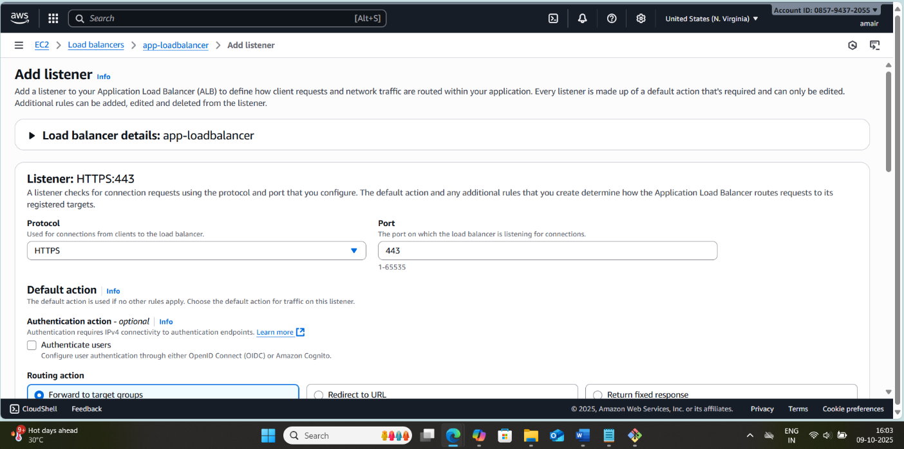

2. Request or Import SSL Certificate in ACM
Option A: Request a New Certificate
- Go to AWS Management Console → Certificate Manager → Request a certificate.
- Choose “Request a public certificate” and click Next.
- Enter your domain name (e.g., example.com or *.example.com for wildcard).
- Validate domain ownership using:
  - DNS validation (recommended)
  - Email validation
- Once validated, ACM issues the certificate.
Option B: Import an Existing Certificate
- Go to ACM → Import a certificate.
- Provide the:
  - Certificate body
  - Private key
  - Certificate chain (optional)

3. Configure HTTPS Listener on ALB
- Go to EC2 → Load Balancers → Select your ALB → Listeners tab.
- Click Add listener → Choose:
  - Protocol: HTTPS
  - Port: 443
- Under Default actions, choose Forward to target group (usually your existing EC2 target group).
- Click Change next to SSL certificate → Choose ACM certificate.
- Select the SSL certificate you added in Step 2.
- Click Save.

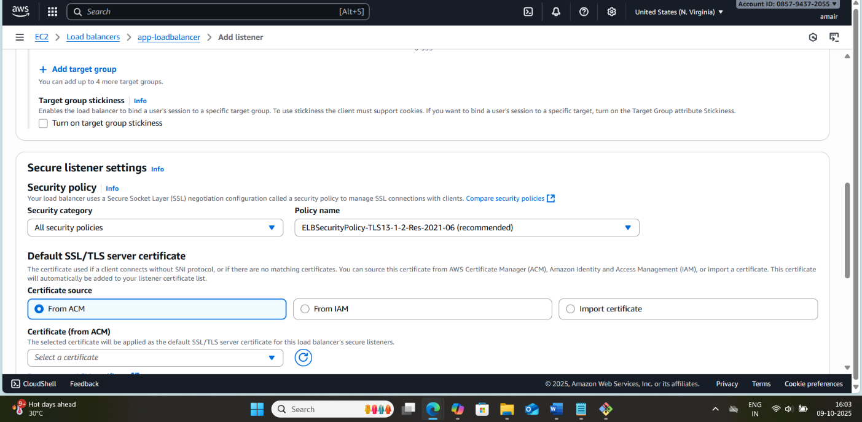
4. Update Security Groups
- Go to EC2 → Security Groups associated with ALB.
- Ensure inbound rule allows TCP 443 from your client IPs or 0.0.0.0/0 for public access.
- Outbound rules should allow traffic to target group instances on their listening port (usually 80 or 8080).

5. Test SSL
- Access your application via https://your-domain.com.
- Check for:
  - HTTPS padlock in the browser
  - Correct domain on the certificate
- Optional: Use SSL testing tools like SSL Labs SSL Test to verify the configuration.

6. Optional: Redirect HTTP to HTTPS
To enforce HTTPS:
- Add a HTTP listener (port 80) if not already present.
- Set Default action → Redirect:
  - Protocol: HTTPS
  - Port: 443
  - Status code: 301 (Permanent)

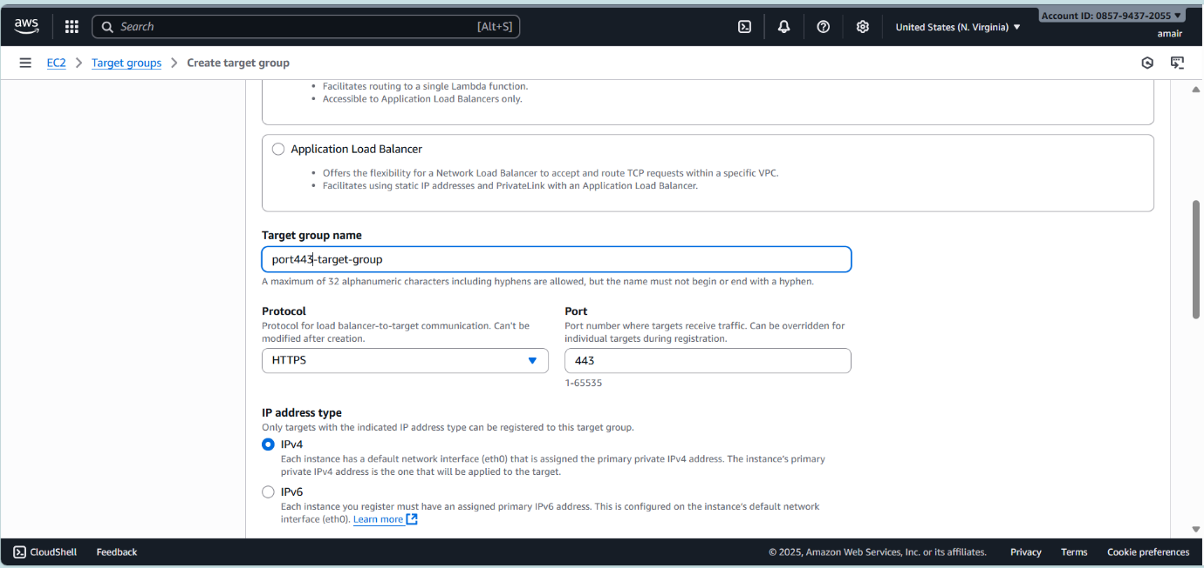

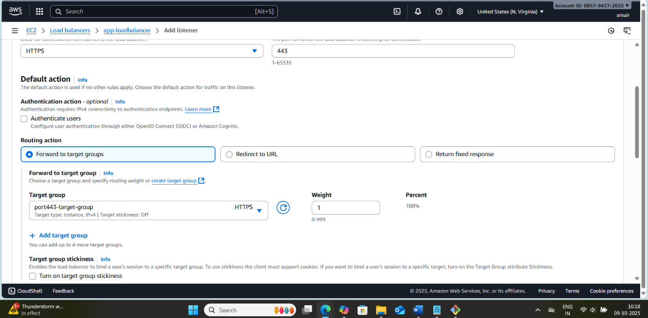

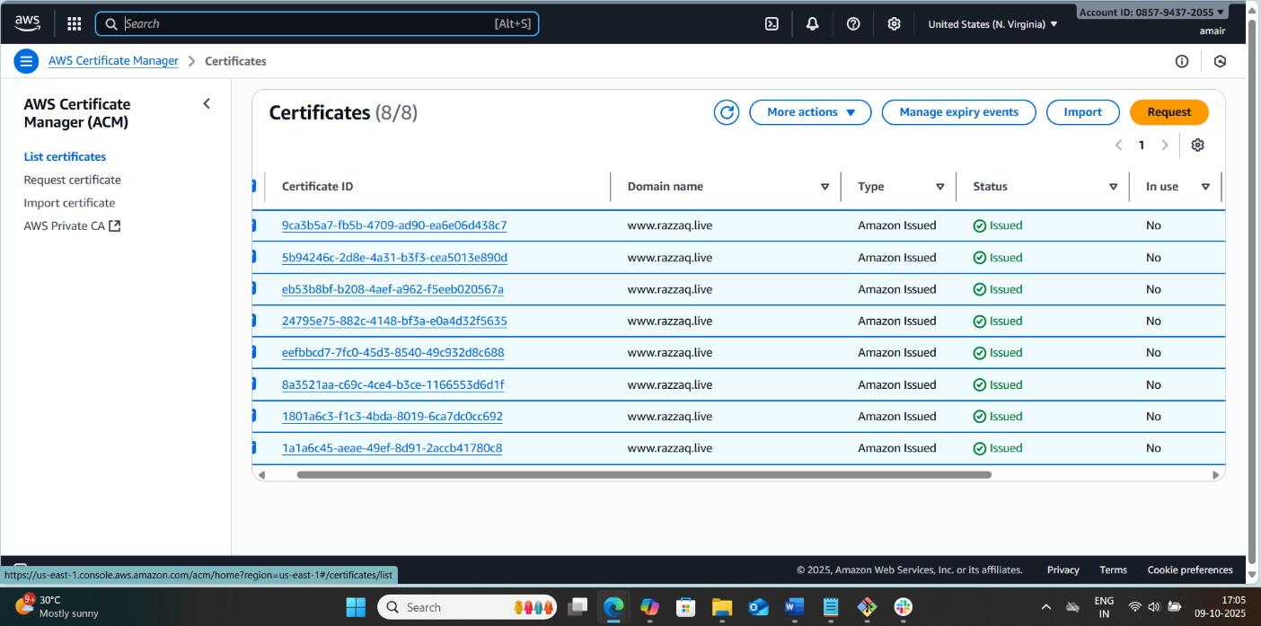
Key Notes
- SSL termination happens at the ALB, meaning traffic from ALB to EC2 can be HTTP (unless you enable end-to-end encryption).
- ACM certificates expire automatically after 13 months and renew automatically.
- Wildcard certificates simplify SSL management for multiple subdomains.

- Map Application load balancer to R53.
Pre-requisites
- ALB is already created and working with target EC2 instances.
- Domain name purchased (e.g., from GoDaddy, Namecheap) or using AWS Route 53 domain.
- Hosted zone created in Route 53 for your domain.
- ALB DNS name is available (from AWS console under Load Balancers → Description → DNS name).

Step-by-Step Execution
Step 1: Log in to AWS Console
- Go to Route 53 → Hosted zones.
- Click on your domain name.

Step 2: Create a Record to Point Domain to ALB
- Click “Create record”.
- Choose Record type: A – IPv4 address (or AAAA for IPv6 if needed).
- Select Alias: Yes.
  - Alias allows mapping directly to an AWS resource (like ALB) without needing IP addresses.
- In Route traffic to, choose Application and Classic Load Balancer.
- From the dropdown, select your ALB.
- Click Create records.
✅ Now your domain (e.g., www.example.com) is mapped to your ALB.

Step 3: Wait for Propagation
- DNS changes may take a few minutes to propagate.
- Test by entering your domain in the browser. It should resolve to your ALB and display your application content.

Step 4: Optional – Redirect Root Domain
- If you want example.com to redirect to www.example.com:
  - Create a record for the root domain.
  - Use Alias to the same ALB or set up S3 static website redirect.

Step 5: Optional – Use HTTPS
- Attach SSL/TLS certificate to the ALB (via AWS Certificate Manager).
- Update ALB listeners to handle HTTPS (443) requests.
- Ensure Route 53 points to ALB, and HTTPS requests are served securely.

Diagram of Flow
User Browser
|
v
Route 53 (DNS)
|
v
Application Load Balancer
|
v
EC2 Instances / Target Groups

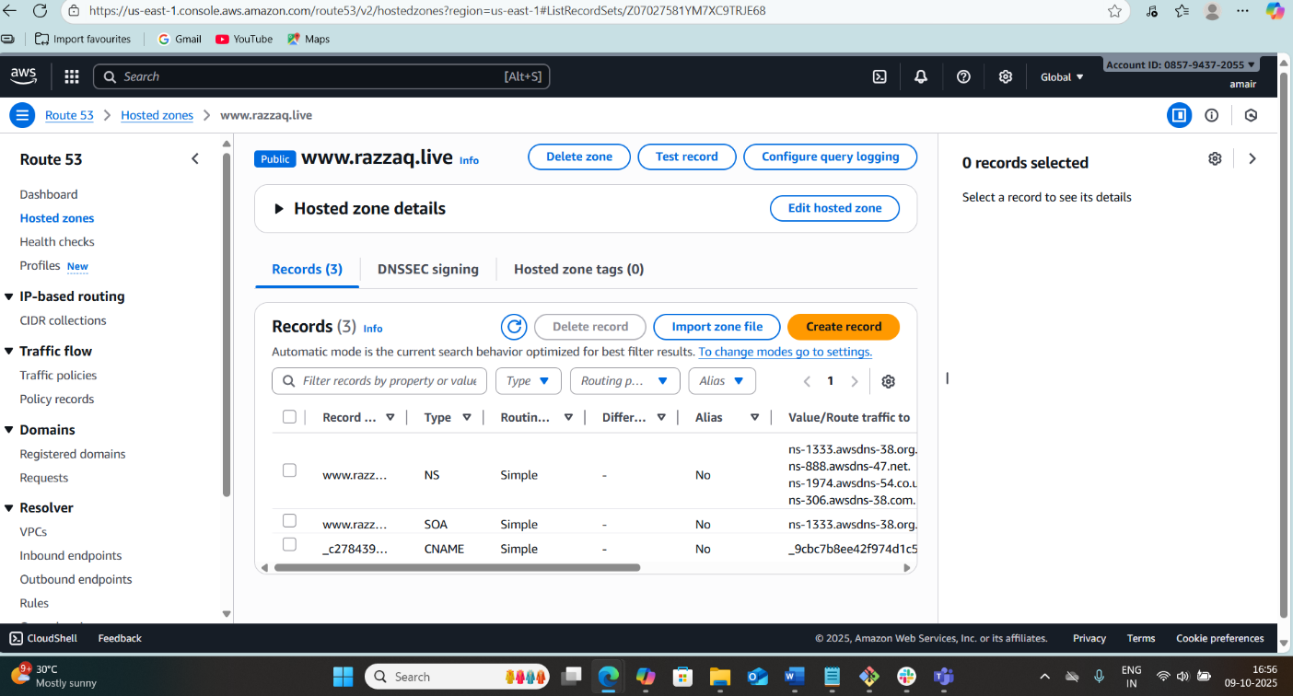

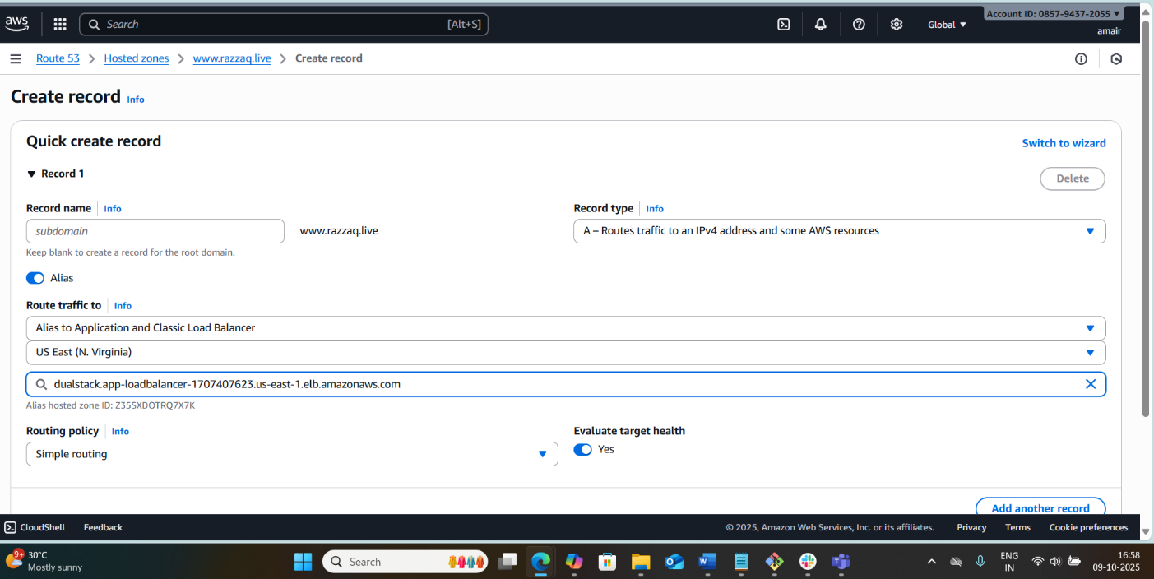

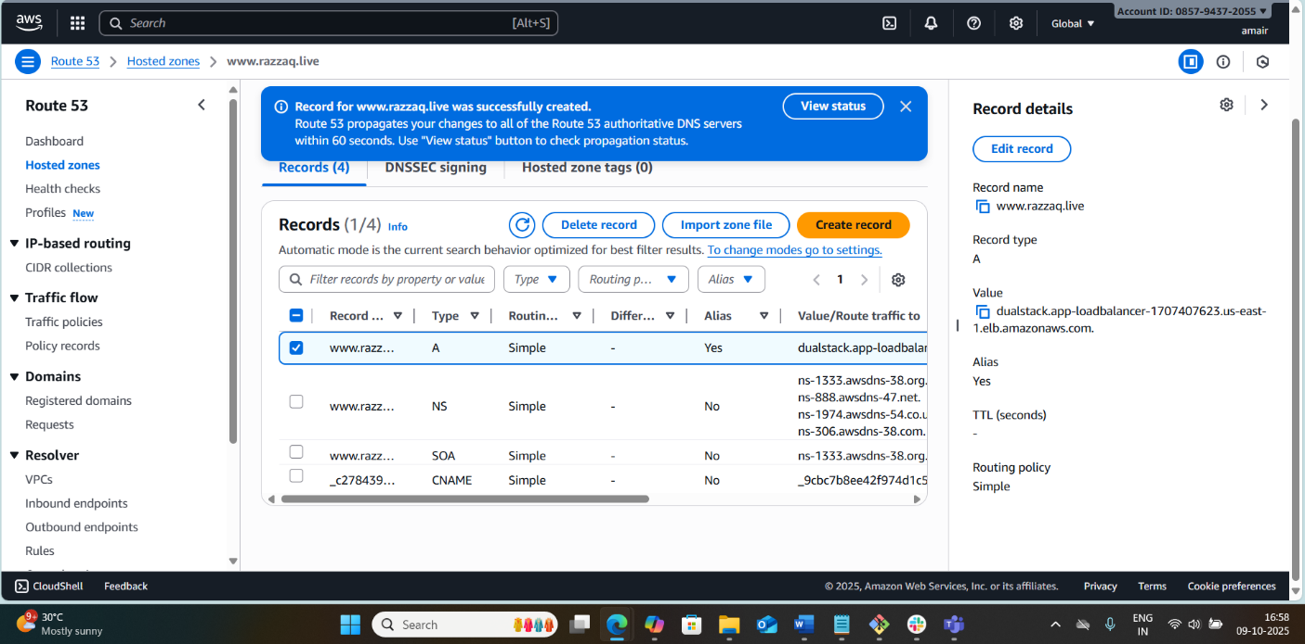
Important Notes
- Do not use the IP address of ALB; it can change. Always use the DNS name with Alias.
- Propagation time: May take 1–10 minutes.
- HTTPS traffic: Must configure SSL on ALB, not on Route 53.

- Push the application load balancer logs to S3.
- Overview of ALB Access Logs
Application Load Balancer (ALB) can generate access logs that capture detailed information about requests sent to the ALB. These logs include:
- Client IP
- Request path
- Response code
- Latency
- Target IP
Storing these logs in Amazon S3 allows for analytics, auditing, and debugging purposes.
2. Prerequisites
Before enabling ALB logs, ensure the following:
- S3 Bucket
You have an S3 bucket where ALB logs will be stored. Example: alb-logs-bucket.
- IAM Permissions
The ALB needs write access to the S3 bucket. Specifically, it requires the bucket policy to allow s3:PutObject from the ALB service.
3. Step to Enable ALB Logging to S3
Step 1: Create an S3 Bucket (if not already)
- Go to AWS Management Console → S3 → Create bucket.
- Name the bucket, e.g., alb-logs-bucket.
- Set Region same as your ALB region for faster logging.
- Keep default options for now (can adjust versioning or encryption later).
- Click Create bucket.

Step 2: Attach Bucket Policy to Allow ALB Access
ALB uses the AWS service account AWSServiceRoleForElasticLoadBalancing to push logs. Add the following bucket policy:
{
"Version": "2012-10-17",
"Statement": [
{
"Effect": "Allow",
"Principal": {
"Service": "elasticloadbalancing.amazonaws.com"
},
"Action": "s3:PutObject",
"Resource": "arn:aws:s3:::alb-logs-bucket/*",
"Condition": {
"StringEquals": {
"aws:SourceAccount": "YOUR_AWS_ACCOUNT_ID"
},
"ArnLike": {
"aws:SourceArn": "arn:aws:elasticloadbalancing:REGION:YOUR_AWS_ACCOUNT_ID:loadbalancer/app/*"
}
}
}
]
}
- Replace:
  - alb-logs-bucket → Your bucket name
  - YOUR_AWS_ACCOUNT_ID → Your AWS account ID
  - REGION → ALB region (e.g., us-east-1)

Step 3: Enable Access Logs on ALB
- Go to AWS Management Console → EC2 → Load Balancers.
- Select your Application Load Balancer.
- Go to Attributes → Access logs → Edit.
- Enable Access logs:
  - S3 location: alb-logs-bucket
  - Prefix (optional): e.g., prod-alb-logs/ (useful for separating logs by environment)
- Save changes.

Step 4: Verify Logging
- Access logs are not instant. It may take 5–10 minutes after requests are sent to ALB for logs to appear.
- Check your S3 bucket for logs in the following format:
s3://alb-logs-bucket/prod-alb-logs/AWSLogs/<account-id>/elasticloadbalancing/<region>/YYYY/MM/DD/...
- Files are usually .log.gz compressed.

Step 5: Optional – Automate Analysis
Once logs are in S3, you can:
- Use Athena – Query logs using SQL.
- Use CloudWatch – Forward S3 logs to CloudWatch for monitoring.
- Use AWS Glue – ETL processing for analytics.

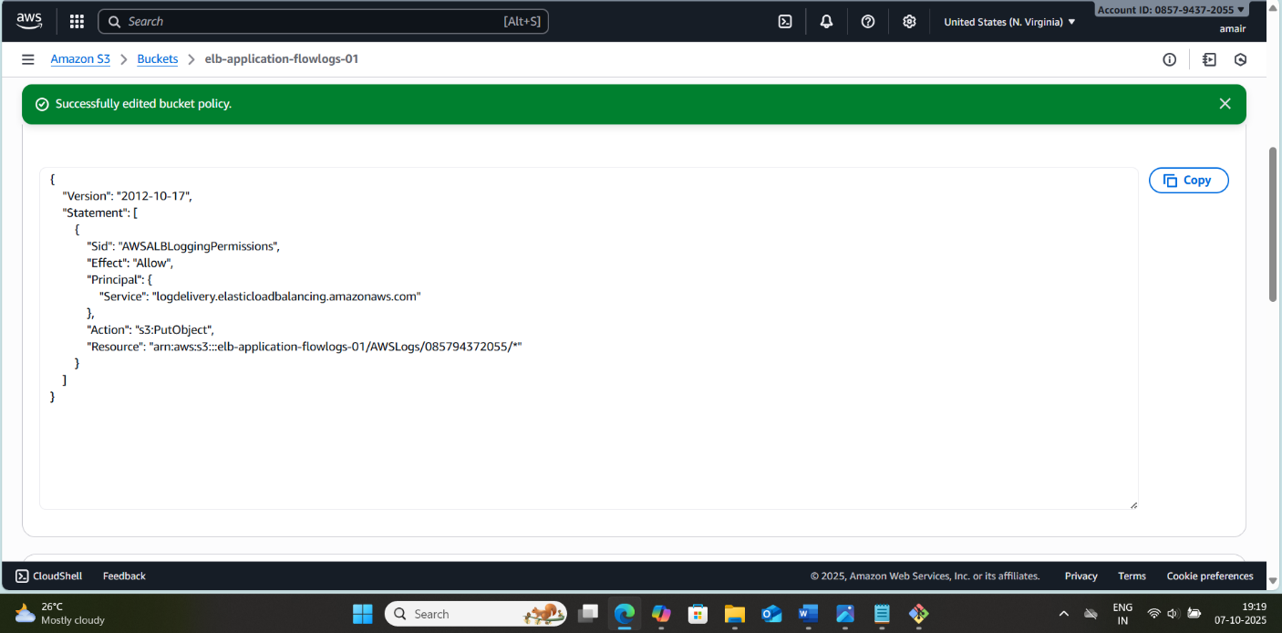

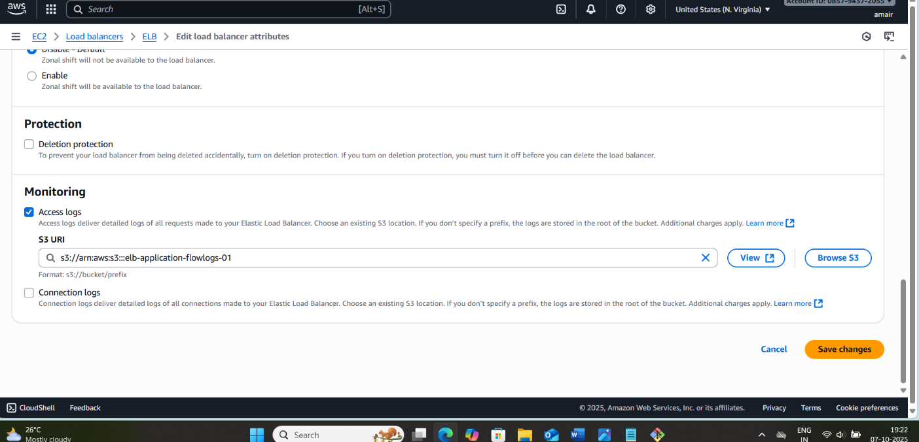

`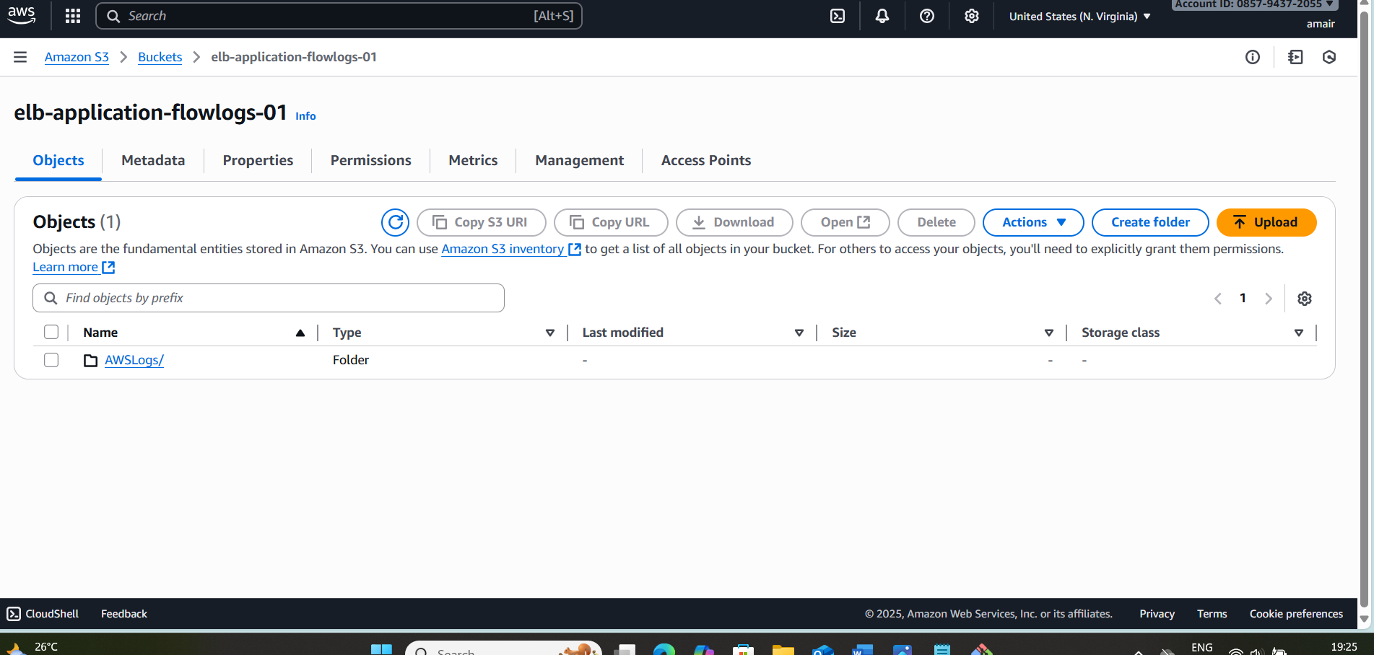

4. Important Notes
- Ensure ALB and S3 bucket are in the same region for better performance.
- ALB writes logs asynchronously; some delay is normal.
- Do not delete or modify S3 bucket policy; otherwise, logging fails.
- Consider lifecycle rules in S3 to archive or delete old logs to save costs.

